2018.01.08

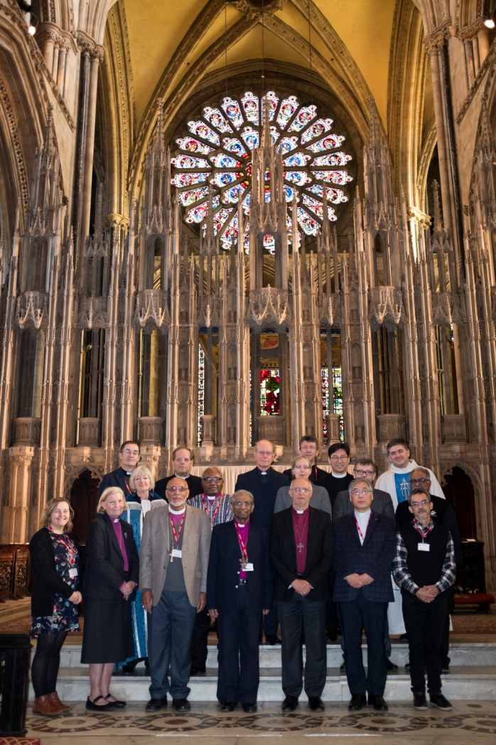

IASCUFO Communiqué 2018

The Inter-Anglican Standing Commission on Unity, Faith and Order met at Durham Cathedral, the shrine of St Cuthbert, from 7 to 12 December, in the Diocese of Durham and the Province of York of the Church of England. The meeting was strengthened and enriched by the Commission’s participation in the cathedral’s worship, including daily celebrations of the Eucharist, morning prayer, and evensong. IASCUFO was delighted to welcome to this meeting the Rt Revd Michael Lewis, Bishop in Cyprus and the Gulf (consultant to IASCUFO), David White (Chief Operating Officer of the Anglican Communion Office [ACO]), the Revd Canon Dr Stephen Spencer (Director for Theological Education in the Anglican Communion [TEAC]), and Ms Lucy Cowpland (Administrative Assistant for Unity, Faith and Order and Communications, ACO).

The Commission was generously hosted by Durham Cathedral, its Dean, the Very Revd Andrew Tremlett, and Chapter, particularly the Revd Canon Professor Simon Oliver (himself a member of the Commission). The Commission was also very appreciative of the hospitality of the Bishop of Durham, the Rt Revd Paul Butler, at Auckland Castle and at his home in Bishop Auckland. Members of the Commission enjoyed engaging with members of Durham University’s Department of Theology and Religion, noting that Durham University validates academic awards for theological education institutions across the Church of England. Members of the Commission appreciated the opportunity to visit the Cathedral’s Refectory Library. They were privileged to enjoy a prayerful and thought-provoking candlelit pilgrimage through the beautiful and historic Cathedral Church, led by Canon Oliver.

IASCUFO’s mandate defines and directs its work. The Standing Commission has responsibility:
• to promote the deepening of Communion between the Churches of the Anglican Communion, and between those Churches and the other churches and traditions of the Christian oikumene;
• to advise the Provinces and the Instruments of Communion on all questions of ecumenical engagement, proposals for national, regional or international ecumenical agreement or schemes of co-operation and unity, as well as on questions touching Anglican Faith and Order;
• to review developments in the areas of faith, order or unity in the Anglican Communion and among ecumenical partners, and to give advice to the Churches of the Anglican Communion or to the Instruments of Communion upon them, with the intention to promote common understanding, consistency, and convergence both in Anglican Communion affairs, and in ecumenical engagement;
• to assist any Province with the assessment of new proposals in the areas of Unity, Faith and Order as requested.

Canon Spencer presented the work of TEAC, in response to which IASCUFO had extensive discussion about theological education across the Communion. IASCUFO was encouraged by the renewed commitment to supporting theological education and resourcing and enhancing theological expertise across the Anglican Communion. IASCUFO commended the proposal that theological colleges should enter into partnerships as a creative way of sharing and enlarging educational and theological provision. Members of IASCUFO will work in conjunction with Dr Spencer and the TEAC team to produce a teaching resource drawing on Anglican ecumenical statements to explore theological and doctrinal questions.

Walking in the Way: Learning to be the Church (2017), the Agreed Statement of the Anglican–Roman Catholic International Commission (ARCIC III) was introduced by the Revd Canon Dr John Gibaut (ACO) and Professor Paul Murray (Durham University), both of whom have made a significant contribution to the work of ARCIC III. IASCUFO was particularly interested in ARCIC III’s use of the methodology of Receptive Ecumenism in this Agreed Statement. It commended the Agreed Statement to the next meeting of the Anglican Consultative Council, Hong Kong, in April 2019 (ACC17). IASCUFO also received and commended to ACC17 the Agreed Statement The Procession and Work of the Holy Spirit (2017) of the Anglican–Oriental Orthodox International Commission. As requested, IASCUFO commented on proposals arising from discussions between The Episcopal Church and the Evangelical Lutheran Church in Bavaria. In addition, IASCUFO considered and endorsed recommendations to clarify and enhance current procedures for the Anglican Communion formally to receive, through a process of study and evaluation, reports and statements arising from ecumenical dialogues.

In the context of its work on the life of the Communion, IASCUFO proposed to Standing Committee that liturgy, and particularly initiation, eucharistic, and ordination liturgies, be included amongst the factors considered when assessing the potential of a proposed new province, along with the potential province’s organisational and financial sustainability, its canon law and its approach to mission.

IASCUFO continues to explore questions of theological anthropology, considering our common humanity as people created in the image of God. Understanding the image of God in terms of divine call and divine gift deepens our comprehension of what it means to participate in and embody the Church’s mission to a broken and hurting world. IASCUFO expects to bring this work on theological anthropology to completion at its 2019 meeting for presentation to the wider Communion.

Members of IASCUFO wish to express their deep gratitude to Canon Gibaut, the Revd Neil Vigers and Ms Lucy Cowpland from the ACO’s Department for Unity, Faith and Order for their outstanding and unstinting commitment to supporting and resourcing not only the work of IASCUFO but also many other dimensions of the life of the Anglican Communion and its ecumenical relationships.

Present:
The Rt Revd Professor Stephen Pickard (Anglican Church of Australia) – Acting Chair
The Revd Canon Dr Steven Abbarow (Church of the Province of South East Asia)
The Rt Revd Dr Victor Atta-Baffoe (Church of the Province of West Africa)
The Revd Professor Paul Avis (Church of England)
The Rt Revd Dr Howard Gregory (Church in the Province of the West Indies)
The Rt Revd Kumara Illangasinghe (Church of Ceylon)
The Revd Nak-Hyon Joo (International Anglican Liturgical Consultation)
The Rt Revd Michael Lewis (Province of Jerusalem and the Middle East)
The Rt Revd Victoria Matthews (Anglican Church in Aotearoa, New Zealand and Polynesia)
The Revd Canon Professor Charlotte Methuen (Church of England)
The Revd Canon Professor Simon Oliver (Church of England)
Professor Andrew Pierce (Church of Ireland)
The Very Revd Dr Sarah Rowland Jones (Church in Wales)
Professor Paulo Ueti (Anglican Alliance)
The Revd Professor Jeremiah Yang (Anglican Church of Korea)

Visiting from the Anglican Communion Office:
The Revd Canon Dr Stephen Spencer (TEAC)
Mr David White (Chief Operating Officer)

Anglican Communion Office Staff:
The Revd Canon Dr John Gibaut (Director for Unity, Faith and Order)
Ms Lucy Cowpland
The Revd Neil Vigers

Apologies were received from:
The Revd Dr William Adam (Lambeth Palace)
The Rt Revd William Mchombo (Church of the Province of Central Africa)

Photo credit: ACO/ Neil Vigers

IASCUFO will next meet 5–12 December 2019

